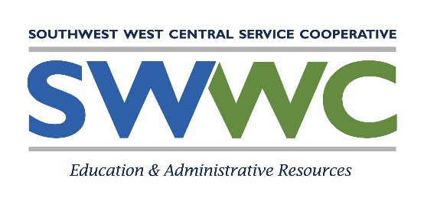
Referral Procedures
STUDENT IDENTIFICATION
“School districts shall develop systems designed to identify pupils with disabilities beginning at birth, pupils with disabilities attending public and nonpublic school, and pupils with disabilities who are of school age and are not attending any school. The district’s identification system shall be developed in accordance with the requirement of nondiscrimination and included in the district’s total special education system plan.”
[M.R. 3525.0750]
- Child Find Activities: SWWC and member districts shall conduct ongoing activities designed to identify students who may require special education. These activities shall include, but are not limited to:
- Community Outreach: Member districts, in cooperation with SWWC and regional Interagency Early Intervention Committees (IEICs) shall prepare and disseminate information regarding available services and referral procedures for students, ages birth through 21, who may be in need of special education. Each district shall insure that such information is available in the native language of its non-English speaking residents. Dissemination may be via public news releases (i.e., newspapers, radio, etc.), school bulletins, brochures, speaking engagements to parent and civic groups, etc. Records of news releases, speaking engagements and copies of disseminated information shall be maintained as appropriate.
- Coordination with Referring Agencies: District and SWWC personnel shall provide information regarding available services, referral procedures, forms, etc. to all community agencies, groups and individuals who have contact with students ages birth through 21. Community agencies and groups shall include, but are not limited to:
- Physicians, clinics and hospitals;
- Public health agencies;
- Public and private social service agencies;
- Public and private schools;
- Head Start, preschools, nurseries and day care facilities;
- Mental health service agencies; and
- Local chapters of parent and lay associations
- Review of Student Progress: All students shall have their progress reviewed to determine if they may be in need of special education. This shall include, but is not limited to:
- A periodic review of student records, including the results of group testing, by classroom teachers; and
- A review of the education record and/or interview with the parent of each new student by the building principal (or designee).
- Problem Solving: When a student in grades K-12 is having difficulty within the general education setting, a Problem Solving form shall be completed. This form may be completed solely by the referring person(s) or by the referring person in conjunction with the building administrator/others, as appropriate. The completed form is then given to the Student Support Team (this may be referred to by another name in individual buildings). The item will be placed on the agenda of a regularly scheduled Student Support meeting. Problem Solving forms for nonpublic students shall be directed to the school psychologist. The school psychologist will develop a student support time for that student. Note: The referring person(s) must contact the student’s parent(s) and inform them that a Problem Solving form is being completed.

